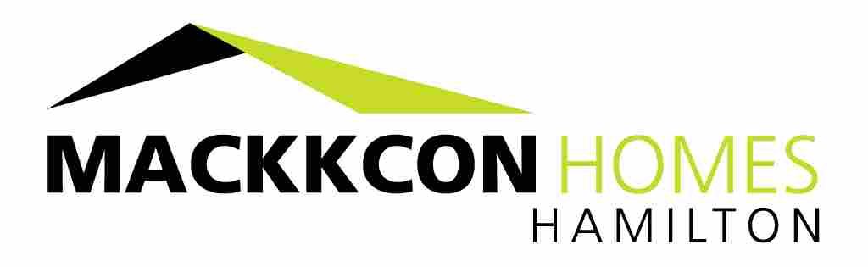
Our 10 Star Excellences
- Association
Members of HIA, MBAV, HRBA & approved Green Living MasterBuilders.
- Competency
Registered Building Practitioners& Full Construction & Customer Warranty Insured.
- One Stop
We do it all. Design, Construct & Deliver.
- Easy Build
Our processes make it stress free for you.
- Communication
We’ll keep you closely informed.
- Inspection
Guaranteed 8 onsite meetings with you.
- Compliance
Building & Independent Engineers inspections.
- Energy Efficient
29 point energy rating check list during construction.
- Quality assurance
15 Contractor compliance checklists for quality.
- After sales Service
Here for you always.

